Configuring Properties

Introduction Spring boot profiles

Now there may be requirement that on various environments we can have different DB configuration this can be achieved by profiling concept provided by Springboot

We can set the current active profile in application.properties with the below property

Spring.profiles.active =prod

Now create the application properties file with appending prod or qa

application_prod.properties

application_qa.properties

depending upon the value specified in profile it will automatically read the properties from that particular file

say in our case application_prod properties will be loaded.

But as microservices grow maintaining properties for each is cumbersome process so will externalize these properties

Now if we want to change the active profile then we have to change the value of spring profile active in all the service related property file . But this is again a cumbersome process so spring boot has provided many different ways to set the properties at run time

Using command line

Command line has highest property over the property defined in application.properties

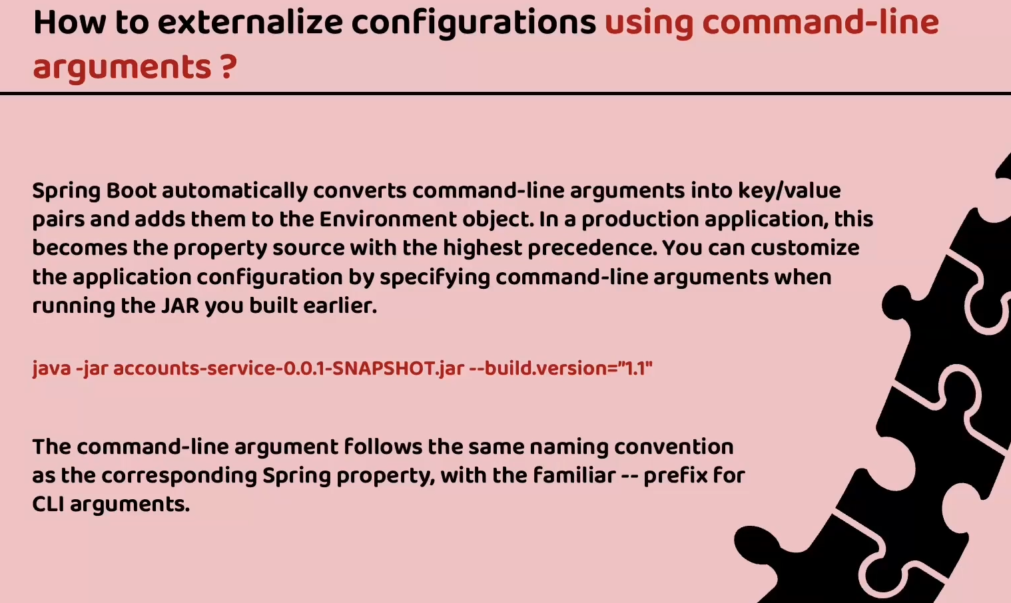

We can also set properties in environment variable . Now to set properties through command line we can set it in the application run configurations

In intellij we can add below to run command

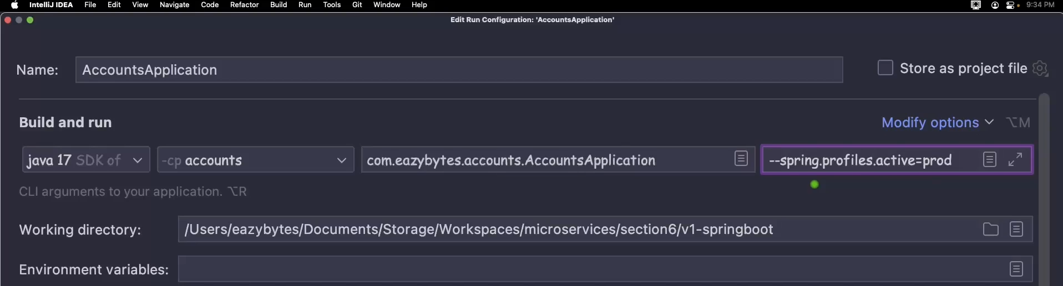

**Introduction to Spring cloud config**

Spring cloud config is a project in the spring ecosystem which helps to create centralized config server. Contains all the properties related to microservices centrally. Centralized repositories can be in file system or github or DB

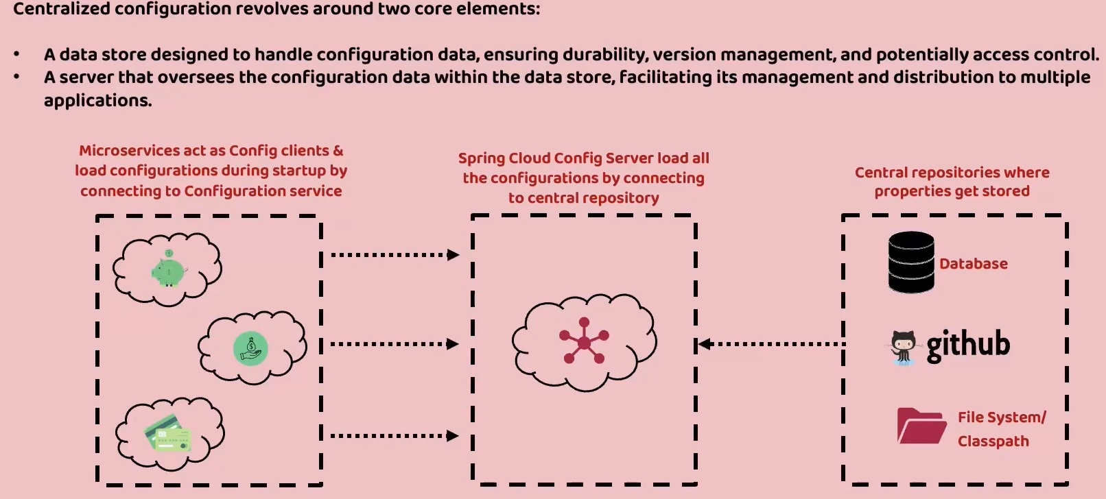

Lets start creating config server create a spring boot application

We should add the dependency Spring cloud config – Config server

Also we need to add actuator which helps in readiness and liveness which will see during further development

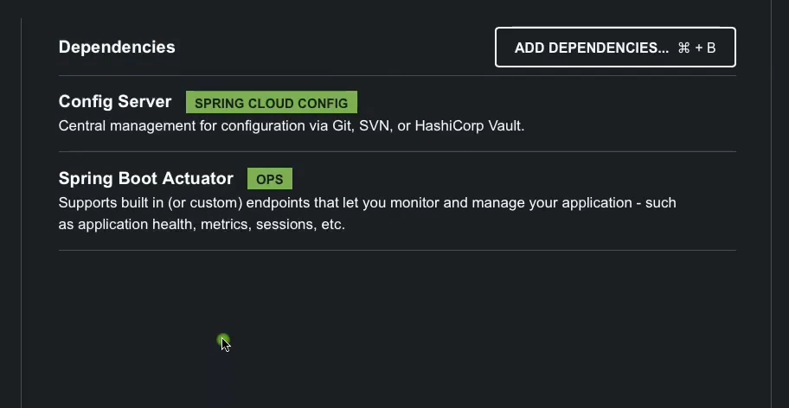

Now once project is created then in the main application file we need to add annotation @EnableConfigServer

Then in the application properties set server port and application name

server.port=8071

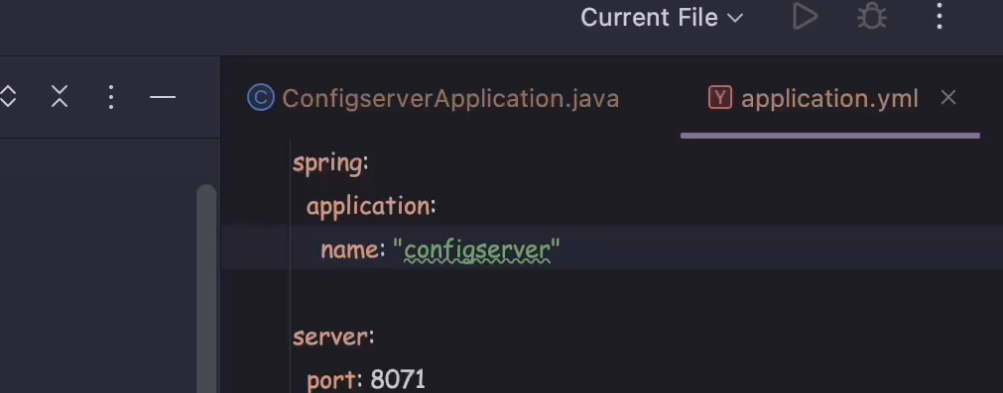

There are various approaches to store the properties in the config server

1. Storing in the class path 2) Storing in the file location 3) Storing on to the central repository like git hub

**Storing in the class path**

So first will create folder in the resources with name config and copy all the properties file from all the services into it. But we need to rename them to the service name as there will be confusion since all the services will have same properties file names. The service name should be same name as specified in property file service.application.name = accounts

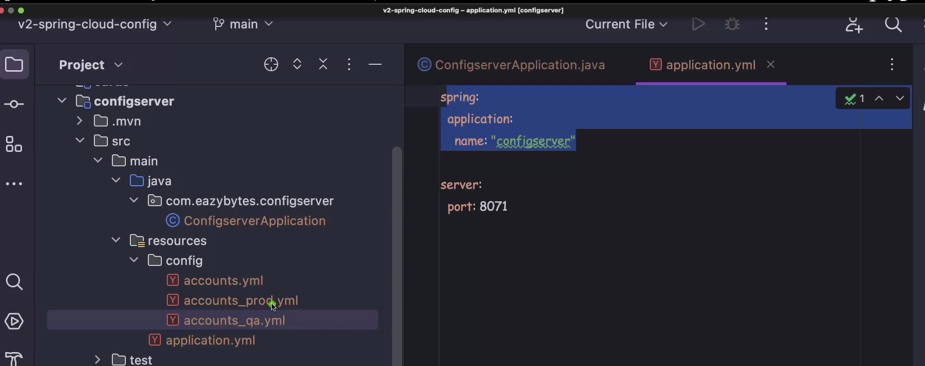

Please note we should use hyphen (-) instead of underscore ( _ ) as below

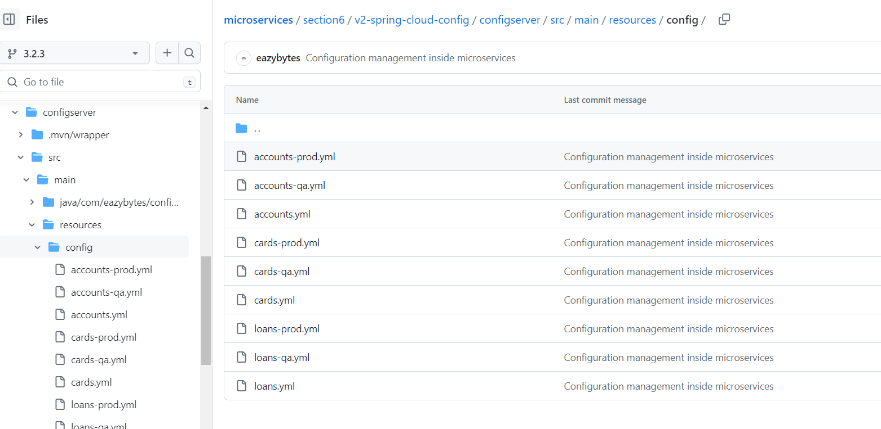

Once all the properties files are added in the config server, then we need to add few properties in the application.properties file of config server

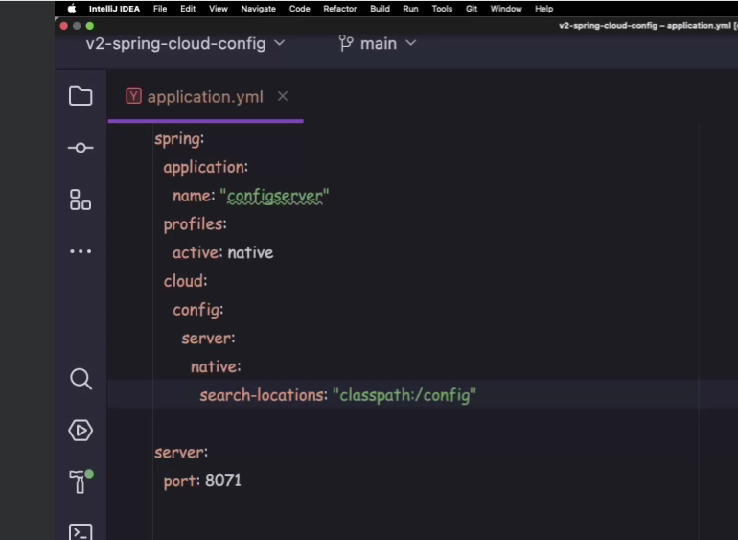

We need to set spring.profiles.active=native . native bcoz all the properties are stored in the same config server in resources folder. We should also set class path so that config server can search the locations

Spring.cloud.config.server.native.search-locations:”classpath:/config”

Config is the folder in resource folder

Now lets making changes in microservices so that it can read the properties from the config server

Delete all the prod and qa related property files from services. Then we need to add a dependency spring cloud config – config client.

We need to also mention spring cloud version config properties as below

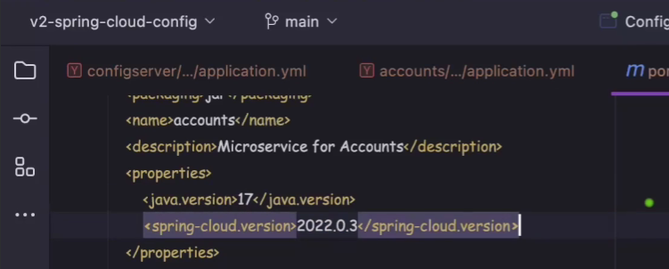

We also need to add dependency management related properties

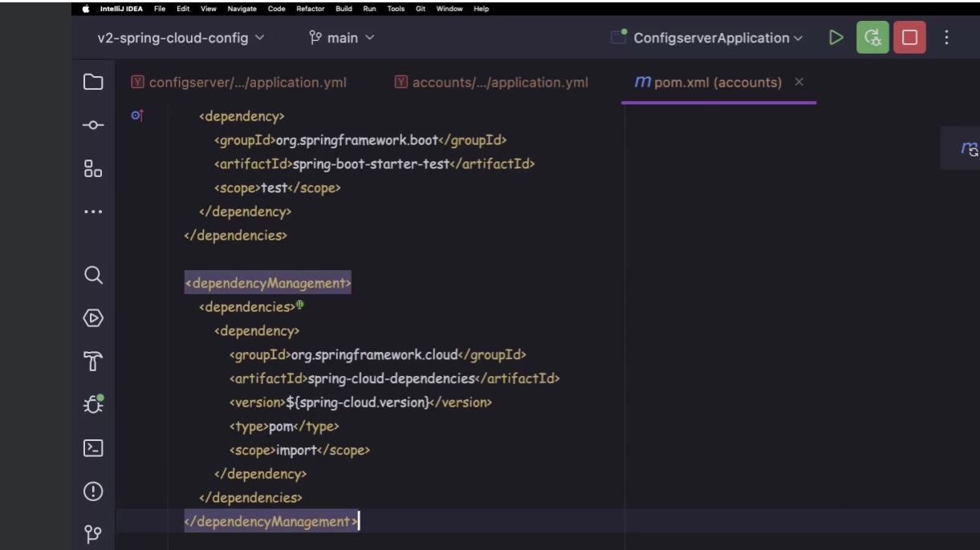

We need to add property spring.config.import to specify the location of the config server and also added application name and spring.profiles.active

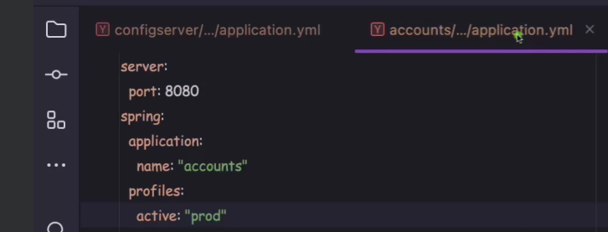

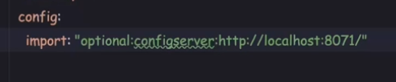

http should always be prefixed with name configserver

First we need to start config server then followed by all other microservices. After starting then prod related properties will be loaded in the services

**Reading configurations from Git hub repository**

Create a repo on git hub with all the property files of services added as below

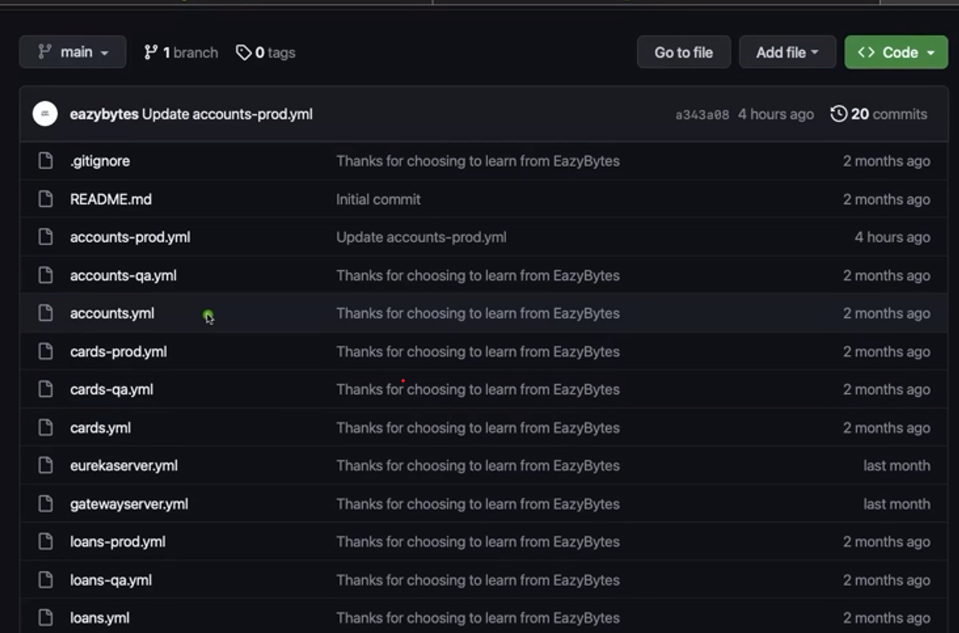

Now we have to change the properties of the config server if we want access property from git hub then profile should be git and then set the git hub repository details and default label is actually the branch name. Also at the startup only we have to clone all the property files so that it doesnot cause any issue later. Force pull should be added so that it ignores all the local changes and after restart it will pull the requests from git hub

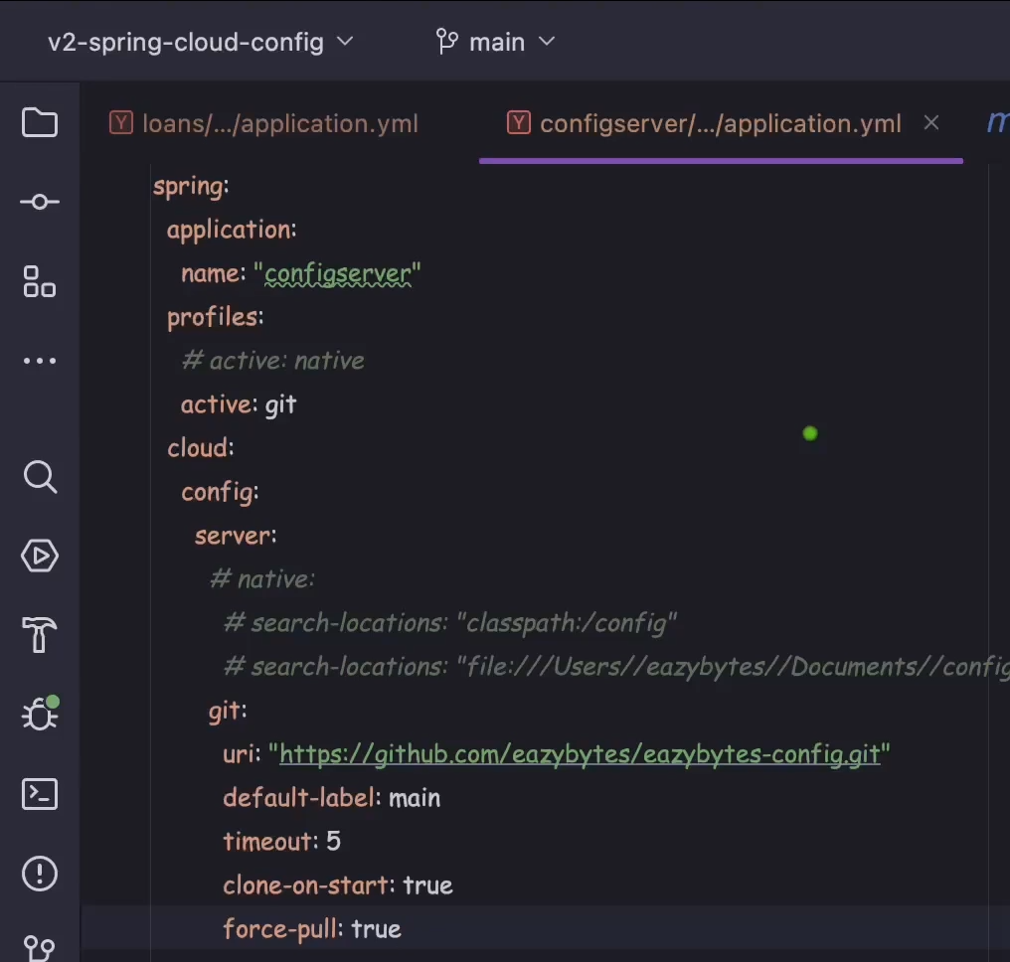

Encrytption & Decrypting the properties

We can also encrypt the properties we can add the below properties key can be any value

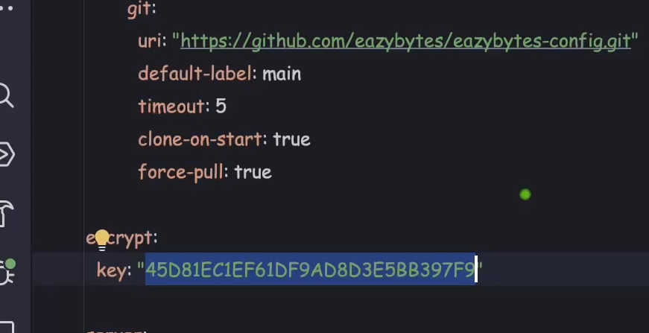

Once you add the encrypt key then our config server is going to expose certain methods through which we can encrypt our data . Now as you can see below that we are accessing encrypt end point to which we are passing some value and it returns the encrypted data

I want to encrypt the email data

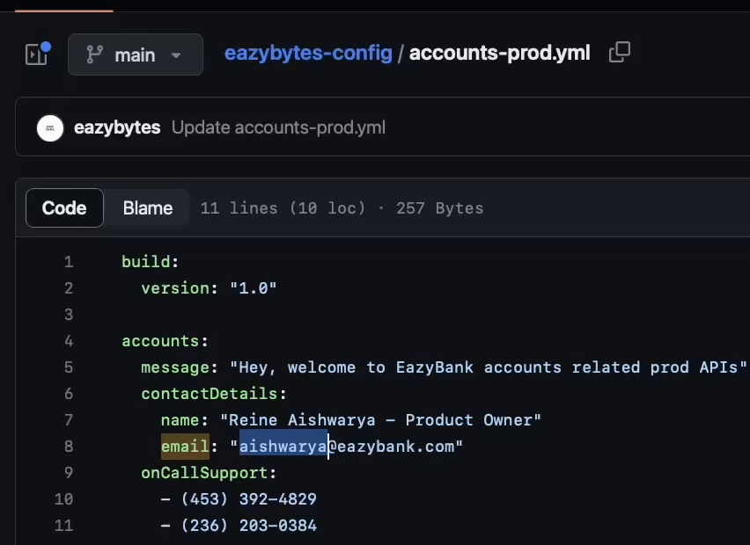

To encrypt this data call config server encrypt method its an in built method

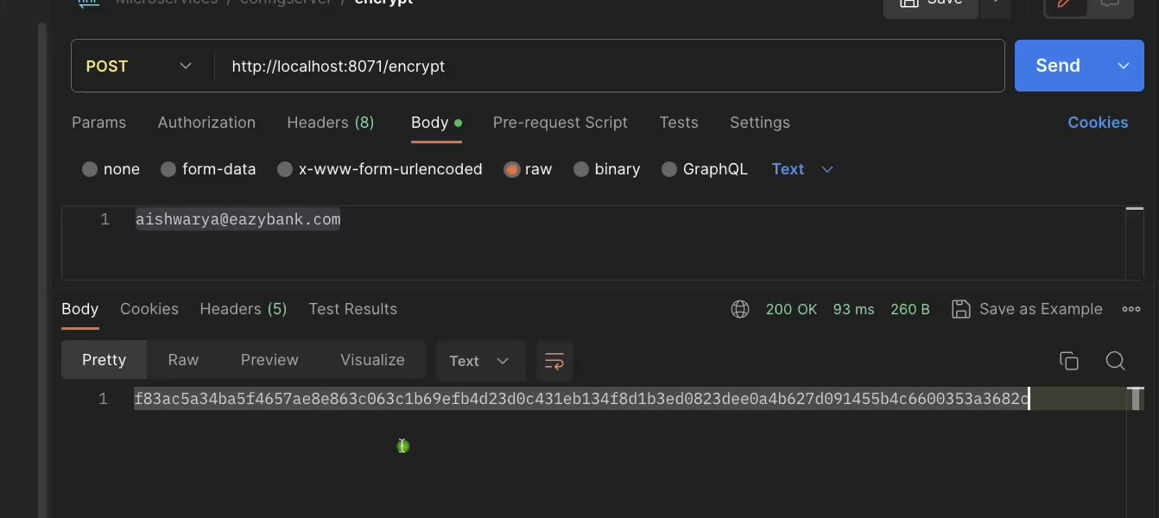

Now once the encryption data is generated then we can set this data in property file

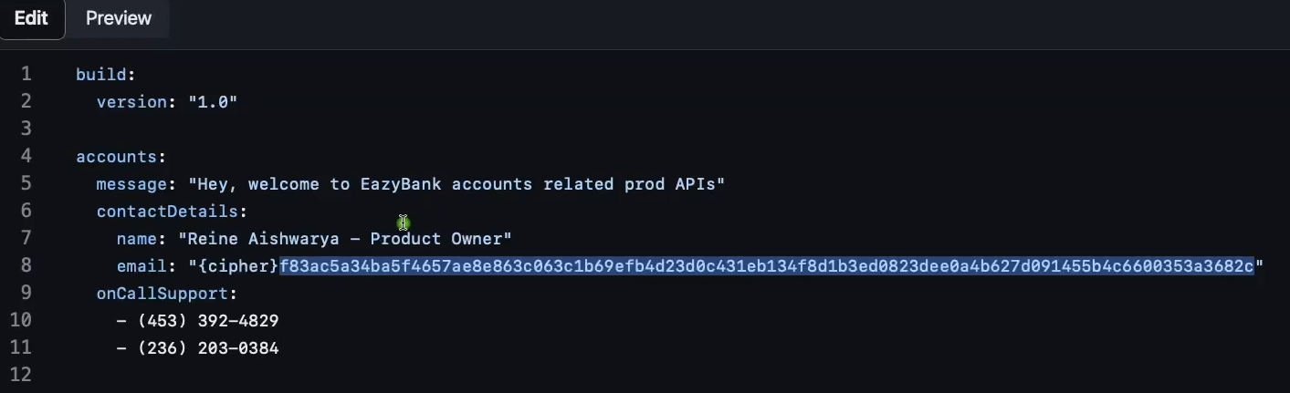

We also need to append {cipher} to the encrypted data bcoz spring boot doesnot understand that whether the data is normal data or encrypted data so with cipher it assumes encrypted data and it tries to decrypt when properties are required

Refresh configuration at run time using actuator

There may be situation that at some point we may add new properties to the property file But to take change or reflect these properties we need to restart the microservices. In real scenario there may be multiple microservices running and restarting them is cumbersome process or may result in some adverse effects so to avoid this Spring provided with an option to refresh the properties at runtime.

First we need to add actuator dependency in all of the microservices

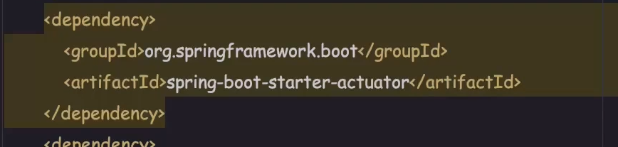

And DTO which reads the properties using configurationproperties

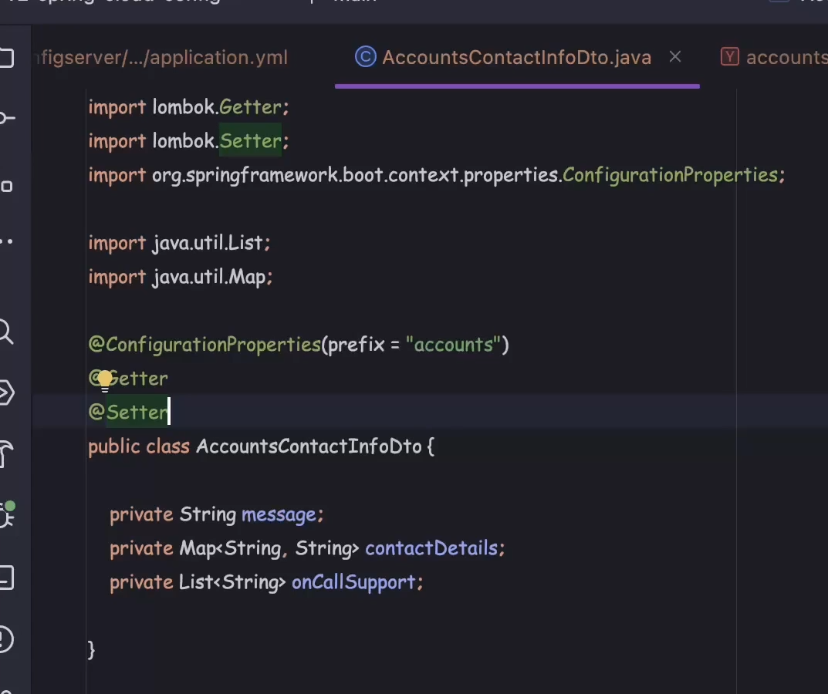

Sample property file

<https://github.com/eazybytes/microservices/blob/3.2.3/section6/v2-spring-cloud-config/configserver/src/main/resources/config/accounts-prod.yml>

Next we need to enable the actuator management methods this can be done by adding management properties in the application.properties file of each microservices

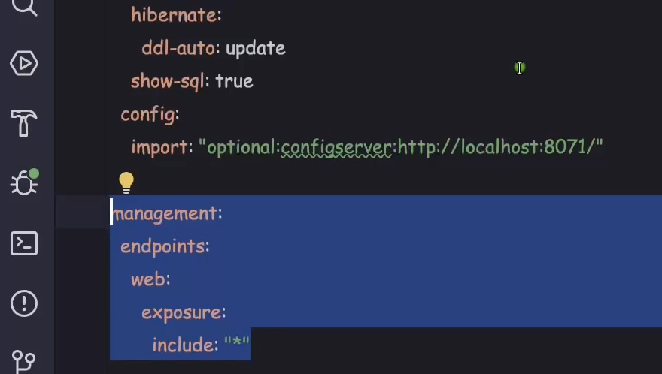

This will expose all the endpoints of web related management methods which includes refresh method.

<https://github.com/eazybytes/microservices/blob/3.2.3/section6/v2-spring-cloud-config/accounts/src/main/resources/application.yml>

Once the configuration is done then start the config server and the start all the microservices

Now lets make some modifications in one of the property file present on the git hub for accounts service

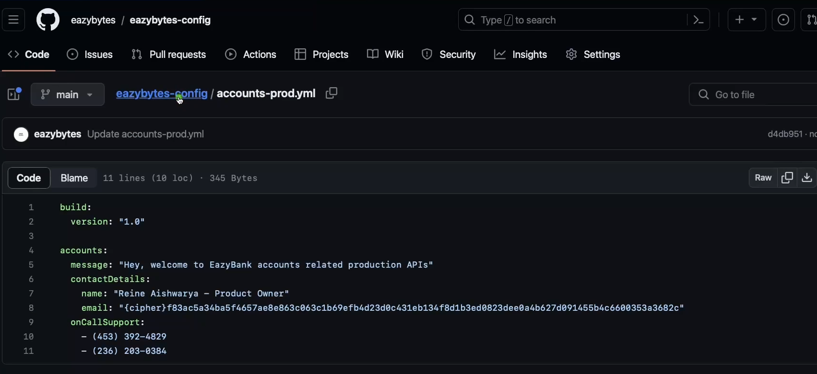

Here prod is changed to **production** in message content

However when you access the property through config server it is always going to return latest changes. <http://localhost:8071/accounts/prod> .

But for microservices we need to restart the services to reflect the new changes so this can be avoided by calling refresh method from actuator of microservices.

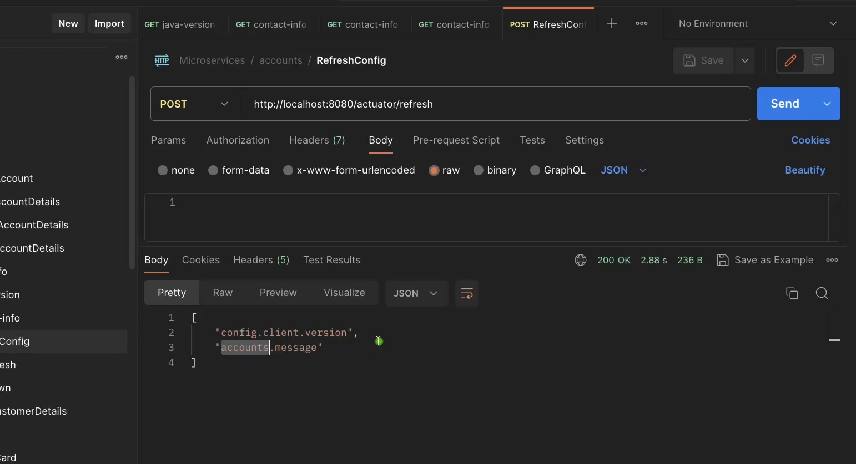

We need to invoke refresh method doing from postman as it is a post method and it will return the property name that got changed and the same will be reflected in the accounts service.

Now lets invoke the API that reads the property data as you can see now message has latest changes as

below

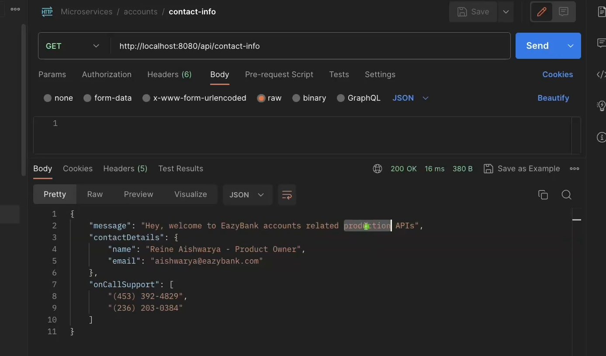

But this is also cumbersome process as we need to invoke each and every service’s refresh method. We can avoid this by using Spring cloud bus. Spring cloud bus works in collaboration with light weight message broker like rabbitmq or kafka. Spring cloud bus works by interlinking each node(microservice) with the message broker. And if we invoke spring bus refresh method of any one of the service then message broker will automatically refreshes all the services linked to it.

First we need to install rabbitmq in our system this we can install it using docker run command as its image available in docker hub

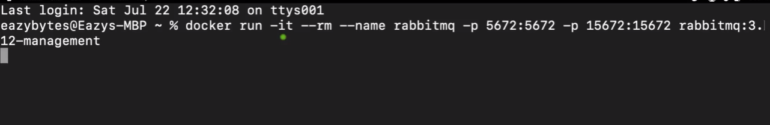

Command to install rabbitmq. Once the installation is done then we need to add Spring cloud bus dependency in each of the microservices

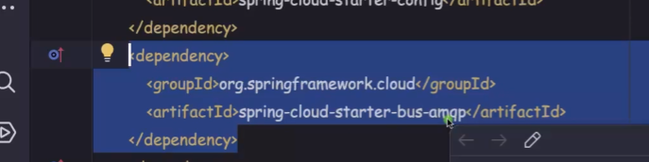

Spring cloud bus contains bus refresh method which we need to expose but we have already added management related properties in each service property file so it will automatically expose this method.

Now to get this node registered with rabbitmq we need to set rabbitmq related properties in all the microservices

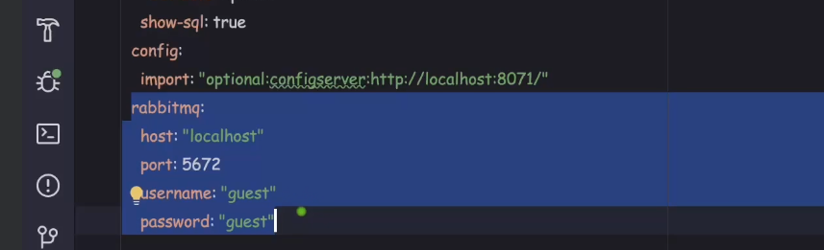

Now call busrefresh method of one of the services

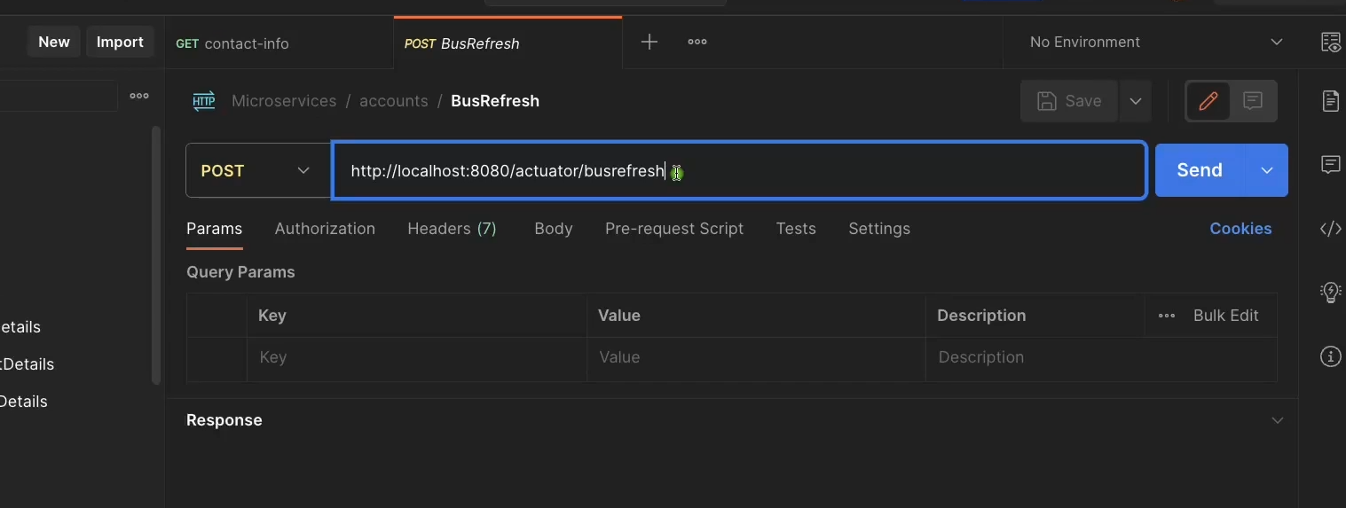

Now it will refresh all the properties of all the services by running only one busrefresh method

Another approach of updating refreshing properties is using webhook. Using webhook we can also avoid calling bus refresh method.

We need to add new dependency in config server know as spring-cloud-config-monitor

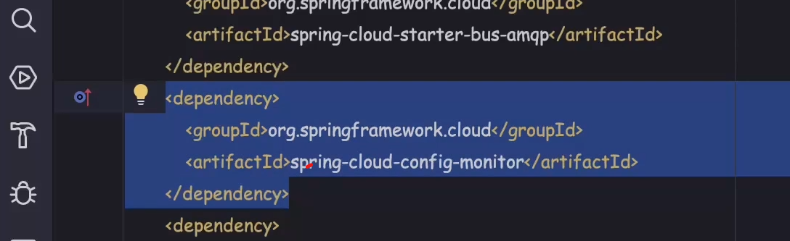

Now this will expose a monitor method in config server. Then we need to configure this method in the github repo so any change in the git hub property file would trigger refresh in all the services

To expose monitor method we need to add management properties in config server application.properties file

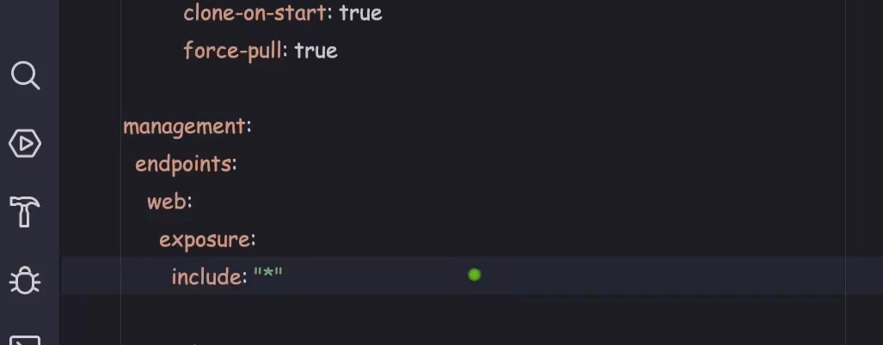

Also we need to add rabbitmq related properties in config server

Then on git hub repo add the web hook related info but this accepts config server URL which is localhost in our case

<http://localhost:8071/monitor> but this is local which cannot be accessed in the git hub as its not public URL. We should make this public URL. We need to use hookdeck to make localhost URL as public IP.

Goto hookdeck.com and click testwebhook.

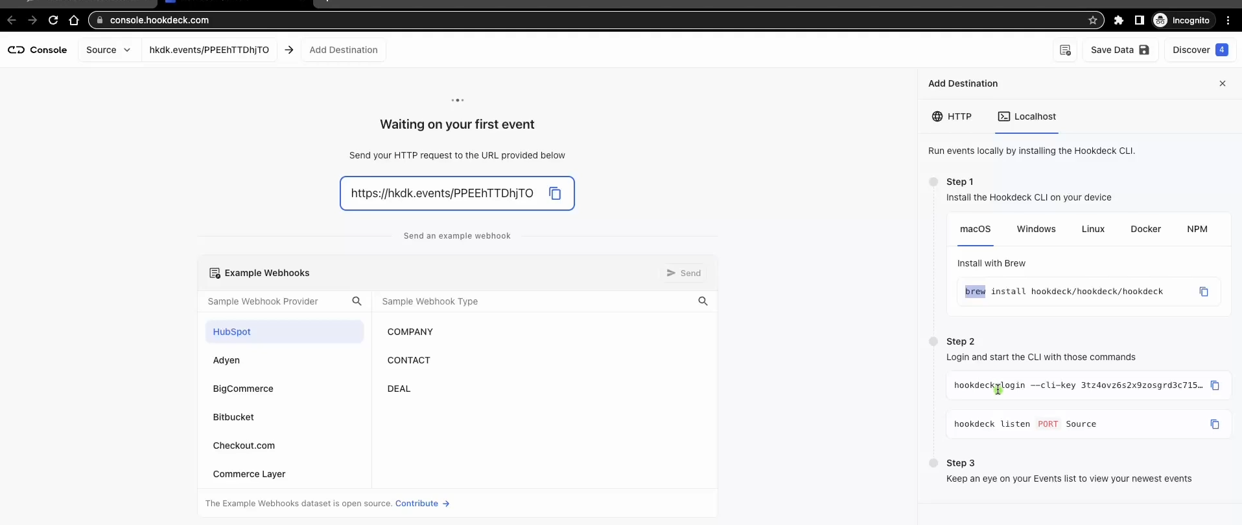

Then click on the add destination and click local host then run all the commands. Then it will ask for the endpoint we need to add monitor then label will be localhost once the webhook URL is generated then set this path in the git hub webhook

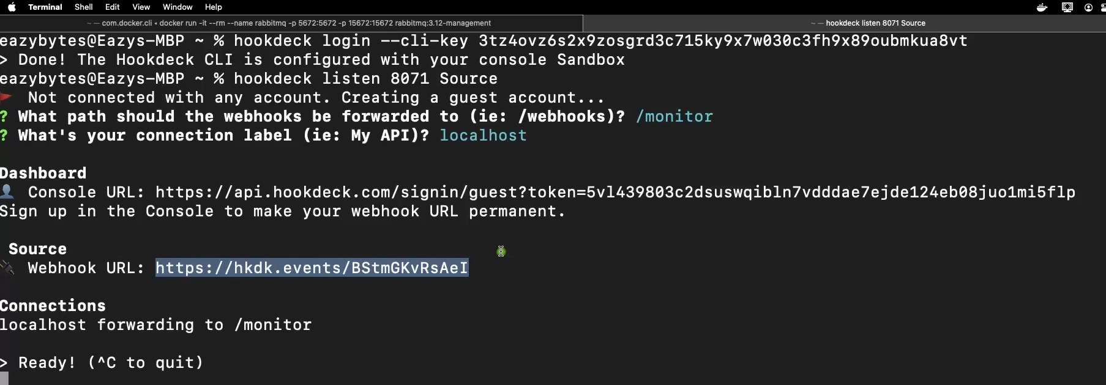

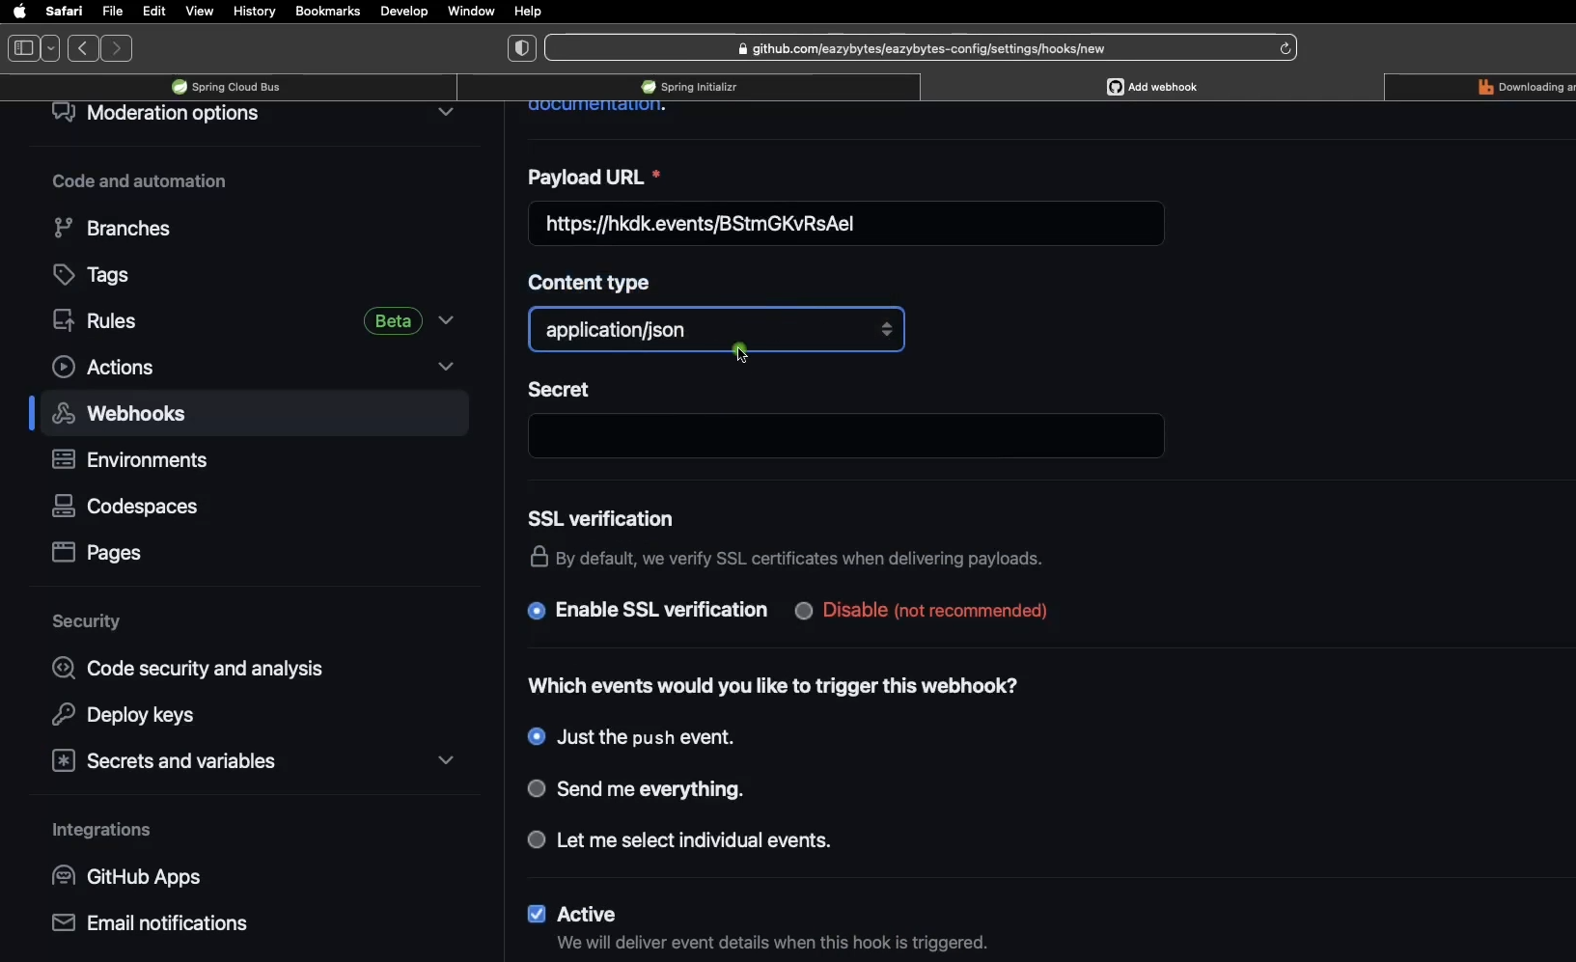

Running config server using Docker compose file

Add config server related to properties in docker compose file

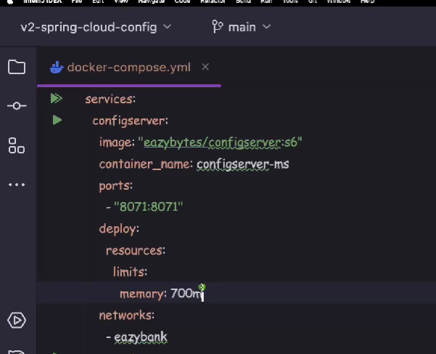

Now we need to configure microservices that how these will communicate with the configserver in a docker service environment .

Earlier we had added below properties to comminucate with config server



But here we are accessing with localhost which will work when we are running it as separate spring boot application

But when we run the services inside a docker host then each container will run in its own isolated network and environment. Therefore all the microservices will start looking for above Url in its own environment network which is not available and will fail. Therefore we need to externalize these properties with the help of environment variables.

Now in docker compose file add environment property to all the services which takes as similar to services property spring.config.import but this should be in caps and with underscore SPRING_CONFIG_IMPORT



Here localhost is replaced by the service name of the config server in the docker compose file and http should always be prefixed with configserver

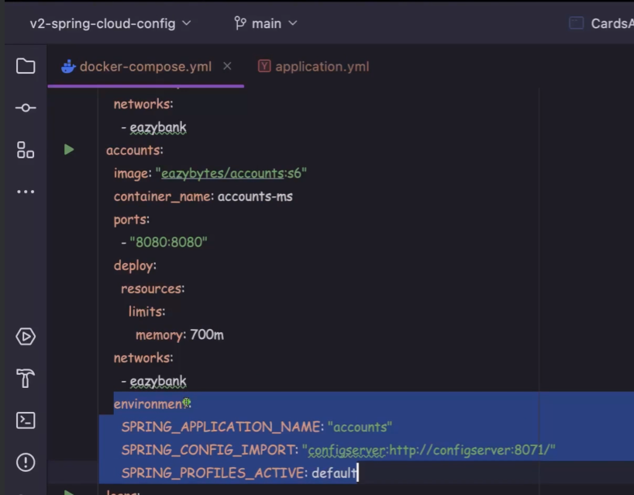

Need to make changes in all the services.

But when we try to run the docker compose up command then it will start the services in the order we have mentioned but docker will not wait for the next service to start until the first that is service config server has started which may cause issue. Hence we need to provide mechanism so that docker will start the next service until the current service has started.

This can be achieved by readiness and liveness

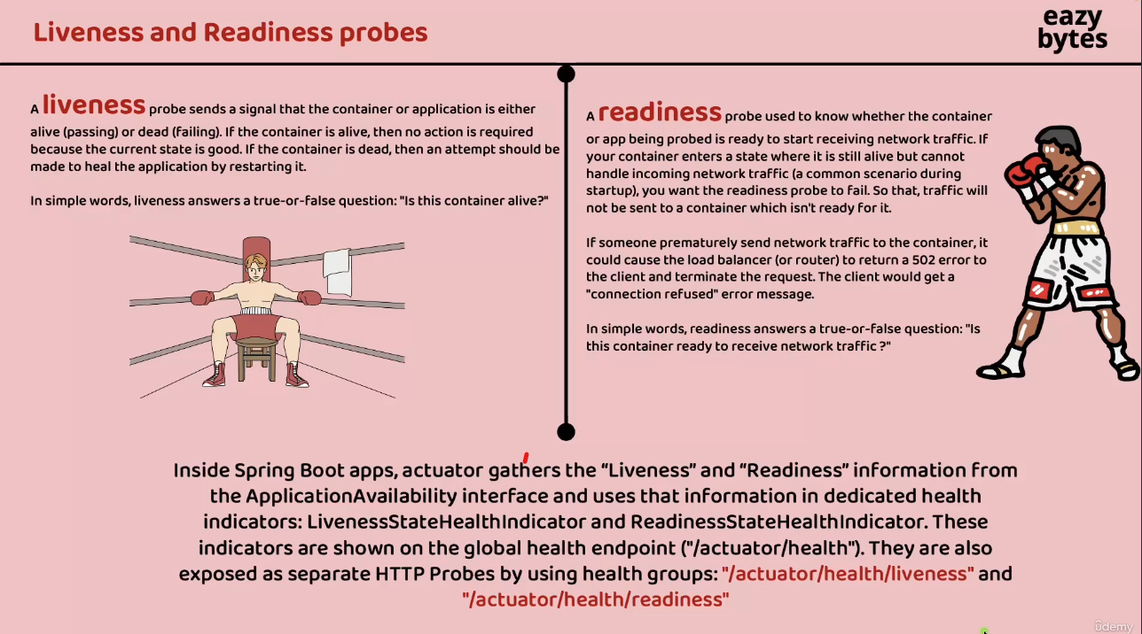

We need to add dependency actuator in config server so that it shares about readiness and liveness information . These end points need to be exposed so we need to add management health related properties in config server application.properties file

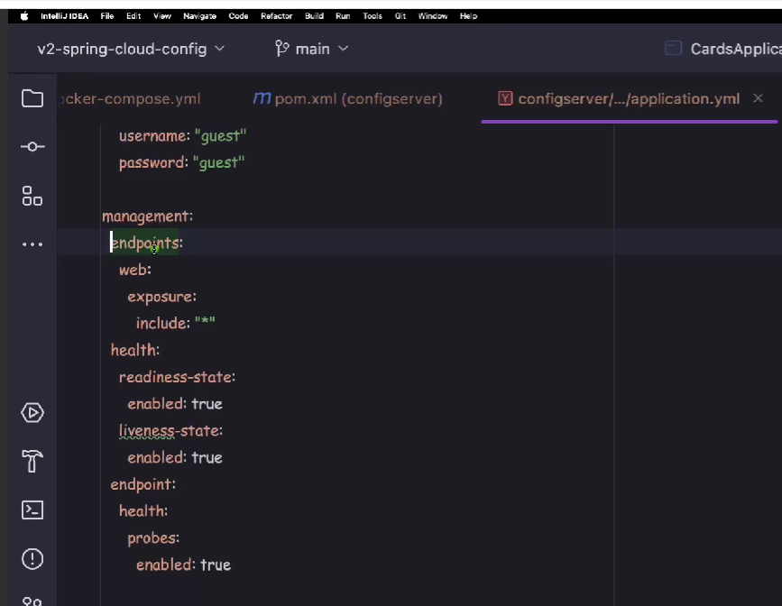

Once you start the config server then you can run health endpoint in browser

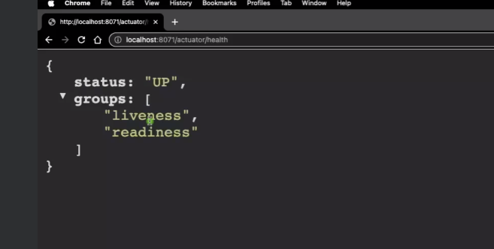

Now lets change in the docker compose file to check liveness and readiness

Now add the properties in the config server which checks the value for UP else it exits the running and wait for intervals 10s if there is no response from server and if server is not responding we can also specify retries.

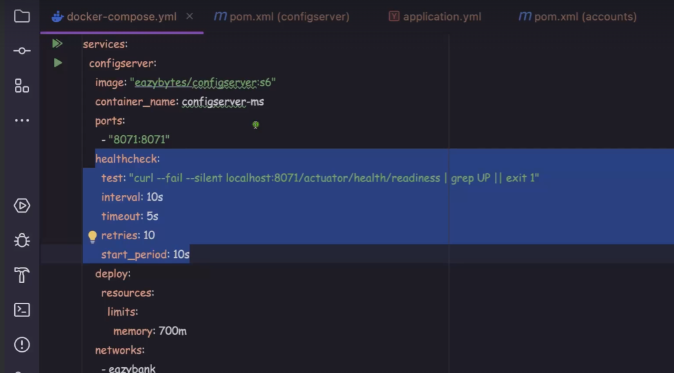



Now in alls service add the below properties which will start after config server

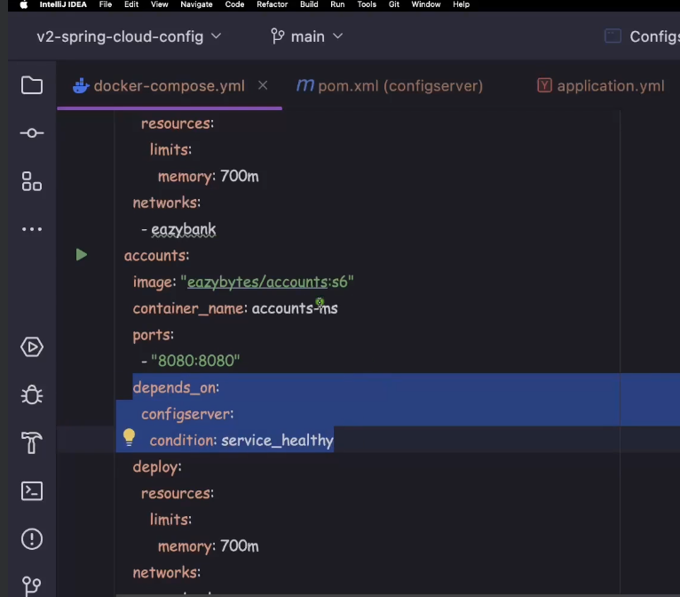

Also if we are using rabbitmq we need to add rabbitmq sevice in docker compose file and rabbitmq is dependent by other services so we need to add health check properties as well

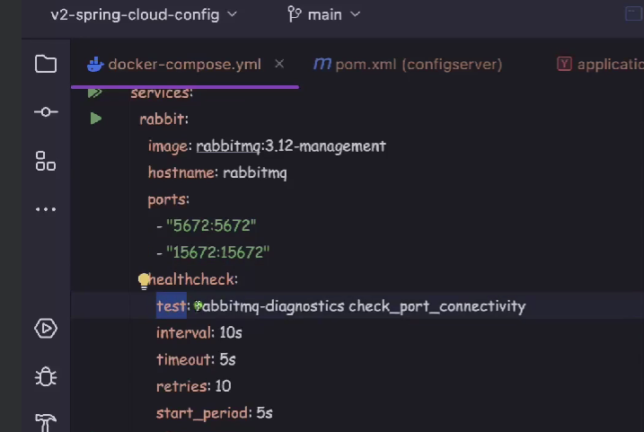

Instead of defining in all services we can check the health of rabbitmq in config server as all other services are dependent on config server. With this config server will wait until rabbitmq is started

